

www.opchatnews.com
Let us feature your Company’s Plans for Optometry Tomorrow
14th June to June 15th 2026

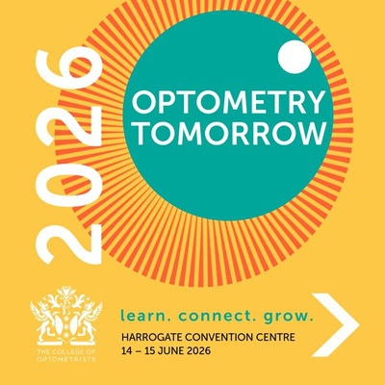
Now receiving your PR and displaying until after the show we will be providing a free showcasing area on our Optometry Tomorrow Preview Pages for those with confirmed stands

Here’s where we will publish your details on Optometry Tomorrow Conference Preview Pages

Just send mail@primaryhealthnet.com a short paragraph on your aims and products or services on display in word format (max 300 words), your company logo (250 pixels sq) and a max of 2 images (max 700 pixels wide ). Don’t forget your Stand Number!

You can add an email address if you need customers to register with you ahead of the show or a link to timetable customers arrivals if so wish.

Coupons and discount codes will also be accepted.

Only word doc. formats will be accepted along with jpeg or png image files no greater tan 700 pixels wide

Opchat News is read by over 7500 opticians each week and is the sole media partner for the College.

We will be sending out two Opchat News E-blast to over 5000 registrants around the 14th June and the 7th July 2026

This is a free service provided by Opchat News, partners of Optometry Tomorrow
This year our previews positioning will be on a first come basis

So, your position on the page will be determined by your speed of sending in your details so don’t delay!

Send to:
mail@primaryhealthnet.com

We are starting to compile the Preview Pages now

